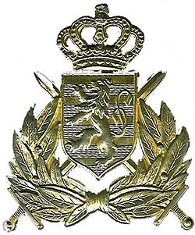

Luxembourg in 2303
Luxembourg has a long and honorable tradition of service to the international community. After World War 2, Luxembourg signed the Treaty of Brussels, and was a founding member of NATO. In the Twilight War they fought bravely alongside international troops with the ACE Mobile Force in Norway against Warsaw Pact forces. However, in January 1998 the French and Belgian armies occupied the west bank of the Rhine, attacking through Luxembourg and The Netherlands as they advanced. The Franco-Belgian forces then created a buffer-zone on the western bank which became little more than a free-fire zone. Luxembourgish forces moved back in-country, reorganized as best they could and took the war to the French and Belgian rear areas. The government reformed and began to regain some control over the countryside, trying to bring some stability to the area. But Dutch, French and Belgian operations continued to destabilize the area, and it appeared that the French would lose patience and invade the rest of the Netherlands, but the British moved troops into the Arnhem area causing the French to back down.
The Treaty of Arnhem in 2007 was the foundation of what would become modern Luxembourg. The French withdrew from the west bank of the Rhine River; the Netherlands would take control of German territory on the west bank of the Rhine down to the Moser River to the German border with Luxembourg. The French were to annex Belgium, which would become a Department of France. The French wanted Luxembourg as an autonomous Department, self-governing and able to have a military, but the British said no. But the treaty did add to Luxembourg the municipalities of Arlon, Attert, Aubange, Bastogne, Fauvillers, Martelange, and Messancy from the administrative districts of Arlon and Bastogne in Belgium; returning the Luxembourgish speaking people to Luxembourg. These new additions would take time to integrate back into Luxembourg, but they would become staunch supporters after a few decades. Luxembourg would also become neutral, keeping the Ardennes closed.
Luxembourg spent the better part of the 21st and 22nd century rebuilding its economy, infrastructure and helping her people. As the 22nd Century came to a close, Luxembourg made the same political decision as the Dutch; not to try and become a starfaring nation and to concentrate on improving the standard of living of its own citizens. Luxembourg had become a data haven and financial nation and they decided to continue that way.
By the end of the 23rd century, Luxembourg has again become a “pearl of Europe”. Her people can be found working in most of the major corporations and foundations, especially the financial and shipping ones that make their home in the country. Her military has become involved in many peace-keeping missions, especially during the Central Asian war, and is well-regarded. She has maintained her cultural identity, become a power in the data and financial world, and is self-sufficient in all but energy and some raw materials. Through many of the research foundations in the world, Luxembourg money has been invested in many colony worlds, especially in the French arm. Many shipping companies use Luxembourg as a “flag of Convenience”, since their home offices are in the country.
Even with her independence, Luxembourg has fallen into the sphere of French influence. Her military conducts training exercises at French training areas, and usually follows France’s lead in international politics. The odds are, if Luxembourg were to start an interstellar colony, it would be an enclave on a French world.

Army of the Grand Duchy of Luxembourg
1st Reconnaissance Company; consisting:
HQ platoon
2x deep penetration ISTAR platoons
Special Duties Platoon (special operations)
The Luxembourg Army’s oldest, continuously serving unit. The 1st Recon has been in continual service since long before the Twilight War, and is considered to be one of the premier reconnaissance units in Europe.

2nd Infantry Battalion
Organization of 2nd Infantry:
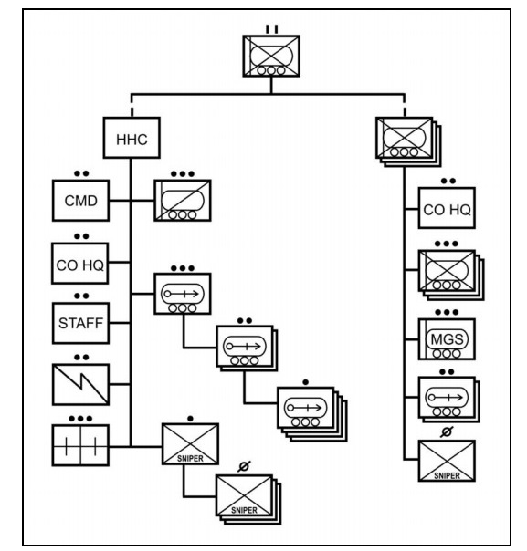
The 2nd Infantry is in the process of re-forming into a mechanized formation; previously it had been a light infantry battalion, operating on foot with little other support. The TO&E above will be completed within the first months of 2303.

1st Infantry Battalion (Grand Ducal Guard); consisting:
HQ & HQ Cpy: administrative and Combat Service and Support for the entire army
A Cpy (Grand Ducal Guard): responsible for the close security of the ducal family, their residence and government offices. The ducal guard also runs the Army’s Officer and NCO academies.
B Cpy: provides the army’s basic training for incoming recruits, and runs the Corporal’s school.
C Cpy: a holding company for replacements, injured and exiting troops. C Cpy still maintains a high degree of readiness, training closely with A Cpy no matter the amount of troops assigned.
1st Infantry varies is size depending on manning requirements in the army. Only HQ& HQ Cpy and A Cpy are fully manned at all times, whereas B and C Cpies maintain only a cadre. The Grand Ducal Guard is the Army’s senior unit.

Grand Ducal Artillery; consisting:
HQ & HQ Bty: contains the army’s FO’s
“A” Bty, 1st Artillery: 4 gun ceremonial battery. Commemorates the country’s contributions to the Allied cause in WW2. Guns are named for the daughters of the then in- exile Grand Duchess of the period.
B Bty: (SHORAD)

1st Aviation Company; consisting:
HQ & ATC Platoon
A Flight: 4x light utility tiltrotors, 1x medium lift tiltrotor
Civilians provide the maintenance for military aircraft.

Ducal Gendarmerie

The Ducal Gendarmerie acts as the army’s military police in time of conflict; providing rear area security, movement control, prisoner supervision, etc. under the Army’s control.

