the newsletter of the society of holistic practitioners
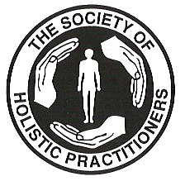 | 
Issue 8 Winter/Spring 2004

Inside this Issue
Regular Items
- Contents
- SHP News
- CHM News
- Massage Corner
- Counselling Corner

Special Features
- The Muscle Map
- Building Your Business

Editorial Team
Editor | Jill Maden
Contributors | Jane Rieck

Contacting Us
Please address all letters, enquiries and ideas for contribution to:

NewsSpace
The Society of Holistic Practitioners
4 Craigpark
Glasgow
G31 2NA

T: 0141 554 5808
F: 0141 554 9036
E: jmaden@maden.globalnet.co.uk
W: www.societyofholisticpractitioners.com

CONTENTS

This issue is full of news about the Society and the massage industry. Changes are afoot and details are included here. The Muscle Map concludes and we also pick up the “Building Your Business” series again and kick off with information and ideas about reaching clients. We hope you enjoy and remember, if there are any aspects of massage or counselling that you would like us to cover, then please let us know at the usual addresses.

- SHP News
Membership Subscriptions
Annual General Meeting
Industry News
Massage Publications
Page 2

- Muscle Map – Muscles of the Arm
Page 4

- CHM News
New Administrator
Page 7

- Counselling Corner
Change of Counselling Accreditation Body
Dalai Lama Comes to Glasgow
Page 7

- Building Your Business – Part 4: Reaching Clients
Page 8

Jill

SHP NEWS

Membership Subscriptions

All membership subscriptions are now due. If you wish to remain a member and have not submitted your renewal form and fee yet, please do so within the next 14 days so that work can commence on this year’s Register of Members.

Annual General Meeting

The Annual General Meeting of the Society was held on Monday 3 November 2003. The Minutes are reproduced below:

Minutes of Annual General Meeting
Held on Monday 3 November 2003

Present: Ron Rieck (College of Holistic Medicine)
Jill Maden (Registrar)

AGENDA

- As there were only 2 people present, it was decided to focus on the following items:

  - Standards of Competence
  - Benefits of Membership
  - Committee Structure
  - Election of Members
  - Review of Accounts

STANDARDS OF COMPETENCE

- At the last meeting, it was agreed that all full members of the Society should update their skills on a regular basis to be eligible to renew their membership. Some discussion took place at this time about what forms of training/supervision would be acceptable, and it was agreed that members should be surveyed for their views on this. The survey did not elicit a sufficiently high number of responses to obtain a representative view, therefore, as the Society is a member of both the British Massage Therapy Council (BMTC) and the General Council for Massage Therapy (GCMT) it was agreed that the Society should take its lead from these organisations. Jill to contact both organisations for further information.

- Once the national standards have been identified, Ron suggested that ways in which the College (and SHP members) could meet them is to provide the following:

  - Professional Review Weekends – these would be run, say, twice a year and be staffed by a qualified tutor. Participants (groups of 16-18) could set the agenda according to their specific needs. These weekends would cost in the region of £100.

  - Supervision Groups – these would run every 2 months for 2-3 hours in an evening. Groups would be made up of 4-6 people. The cost would be around £20 per person per session.

- Ron felt this approach would be more flexible and better able to meet everyone’s needs than the formal training courses provided last year which were poorly subscribed. These options to be reviewed once the national standards are available.

- As both the BMTC and the GCMT are trying to establish themselves as the pre-eminent organisation on massage in the UK and little information has been received from either on their current activities, it was agreed that they should be contacted to provide a summary of the benefits to the Society of maintaining our membership. Jill to contact both for this information.

- In terms of Counselling Members, their Standards of Competence are defined by the BACP, therefore, the above does not apply.

BENEFITS OF MEMBERSHIP

- It was agreed that in addition to the existing benefits one of the main benefits of membership to Massage Members would be to heighten the profile of our members to the massage jobs market.

- This raised the question of “who do you go to to get influence on jobs?”. It was agreed that again, the BMTC and the GCMT would be the best place to start. Potentially, this would mean attending their meetings in London. Cost would be involved in this, and it was felt that an increase in the membership fee may be required to cover these coves. Jill to investigate further and report back.

- Potential employers should then be identified and a promotional compaign put together to explain the advantages of employing graduates of the College of Holistic Medicine/SHP Members. This would include points like adherence to national standards, specific approach of CHM training courses, etc.
- A full strategy should be compiled for doing this. Jill to initiate.

- As regards Counselling Members, as their accreditation with BACP and UKCP is currently being reviewed by the College of Holistic Medicine, and ultimately they may no longer require SHP membership, no further benefits were identified for them at this time.

COMMITTEE STRUCTURE / ELECTION OF MEMBERS

- It was agreed that the “Main Committee” should be renamed the “Steering Committee” as this better reflects its purpose.

- The membership of the Steering Committee should include the following:

  - Representative from the College of Holistic Medicine
  - Registrar
  - A minimum of one full member
  - A student member

- The full member and student member will be identified by the Registrar/CHM Representative.

- These points to be further discussed and agreed at the next meeting.

REVIEW OF ACCOUNTS

- The unaudited accounts for the last 2 years were distributed. These were divided into 3 periods:

  - The 2 months to 31 December 2001
  - The 12 months to 31 December 2002
  - The 10 months to 31 October 2003

- These showed a fall in subscriptions for the most recent period (10 months to 31 October 2003) but Jill explained that this did not include the subscription renewals which would come in in December 2003.

- It was also noted that the Bank Account balance did not matich that in the Accounts. Ron to investigate.

- It was agreed that the following membership fees would apply for the coming year: Full Membership - £25; Affiliate Membership - £8; Student Membership - £5.

Jill Maden, Registrar
12 November 2003

Industry News

In following up her actions from the AGM, Jill has been advised by the British Massage Therapy Council (BMTC) that they have decided to cease operations and that the General Council for Massage Therapy (GCMT) is now going forward as the lead body for massage professionals in the UK. The reason for the BMTC’s decision is that insufficient interest and participation from member organisations meant that decisions which affect all members could not be made.

Jill has subsequently been in touch with the GCMT to ascertain their plans, but has, as yet, not received a response.

Massage Publications

The Society was recently contacted by Curties-Overzet Publications Inc who have recently published a number of books that massage members may find useful:

- A Physician’s Guide to Therapeutic Massage – this explains massage therapy to the physician who wants to be able to provide appropriate patient advice and referrals. Based upon available research about massage therapy efficacy, this text explains applications, indications and contraindications. (US$15.95, CDN$21.95)

- Massage Therapy & Cancer – a manual that combines a basic overview of what cancer is and how it affects the human body with an understanding of the effects, risks, and efficacies of massage therapy. It offers the practitioner reasonable answers and practical information about massage therapy for clients who have cancer. (US$19.95; CDN£24.95)

- Breast Massage – massage and hydrotherapy can offer preventive care as well as gentle and effective treatment of many of the breast conditions women experience. However, massage therapists can be reluctant to offer breast massage. This book helps equip therapists with the knowledge and skills needed to be able to provide breast treatment where appropriate. (US$36.95; CDN$47.95)

For further information, please contact:

Curties-Overzet Publications Inc
330 Dupont Street, Suite 400
Toronto, Ontario, Canada M5R IV9
Web: www.curties-overzet.com

MASSAGE CORNER

The Muscle Map

By Jill Maden

ANATOMY AND FUNCTION OF THE ARM

The arm is comprised of 3 main joints:

- The shoulder
- The elbow
- The wrist

Let’s look at each joint individually to see which muscles affect its movement.

The Shoulder

There are 3 main movement patterns experienced at the shoulder – elevation/depression, abduction/ adduction and inward and outward rotation. These movements are controlled by 3 different muscle groups:

- Group A – these muscles have their origin on the shoulder blade and insert into the upper arm bone (the humerus).
- Group B – these muscles originate on the trunk and insert into the shoulder blade.
- Group C – these muscles have their origin on the trunk and insert onto the humerus.

Group A Muscles

These muscles are primarily responsible for raising/lowering (abducting/adducting) and rotating the upper arm. It consists of the following 5 muscles:

- Supraspinatus
- Teres major
- Infraspinatus
- Teres minor
- Subscapularis (not shown)
Supraspinatus
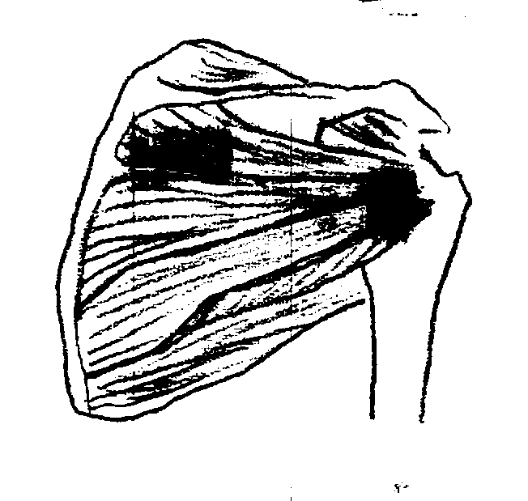
Infraspinatus
Teres major
Teres minor

Figure 1: Group A Muscles
Many of the muscles of the shoulder have Latin names which relate to specific landmarks on the bones to which they attach, making it easier to follow what they do.

Supraspinatus
(supra = above; spina = spine)

This muscle lies below the deltoid muscle and lifts (abducts) the arm and rotates it outwards.

Teres Major
(teres = smooth & rounded; major = greater)

This muscle works with the latissimus dorsi muscle to bring the arm to the side (adduct) and rotate it inwards.

Infraspinatus & Teres Minor
(infra = below; spina = spine)
(teres = smooth & rounded; minor = lesser)

These 2 muscles are located in the gap between the supraspinatus and teres major. Together they adduct the arm and rotate it outwards.

Subscapularis
(sub = under; scapula = shoulder blade)

This muscle covers the inside of the shoulder blade (against the back wall of the rib cage). It adducts the arm and rotates it inwards.

Group B Muscles

There are 3 msucles in this group. Their primary responsibility is for raising the shoulder blade:

- Levator scapulae
- Rhomboids (major and minor)
- Trapezius

Levator scapulae & Rhomboids
(levator = raiser, scapula = shoulder blade)

Both these sets of muscles lie underneath the trapezius. They lift the shoulder and also provide inward rotation.

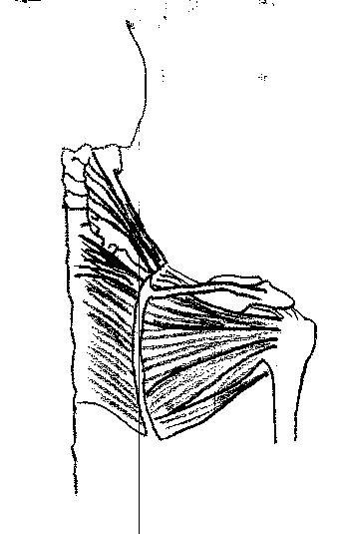
Levator scapula
Rhomboid major
Rhomboid minor

Figure 2: Group B Muscles (Levetator scapulaa & Rhomboids)

Trapezius

This is a large muscle which originates at the base of the skull and from the spines of the cervical and thoracic vertebrae. It inserts into the spine of the shoulder blade and the external part of the collar bone. It raises and adducts the shoulder blade and rotates it outward. It also turns the head and bends the neck backward.

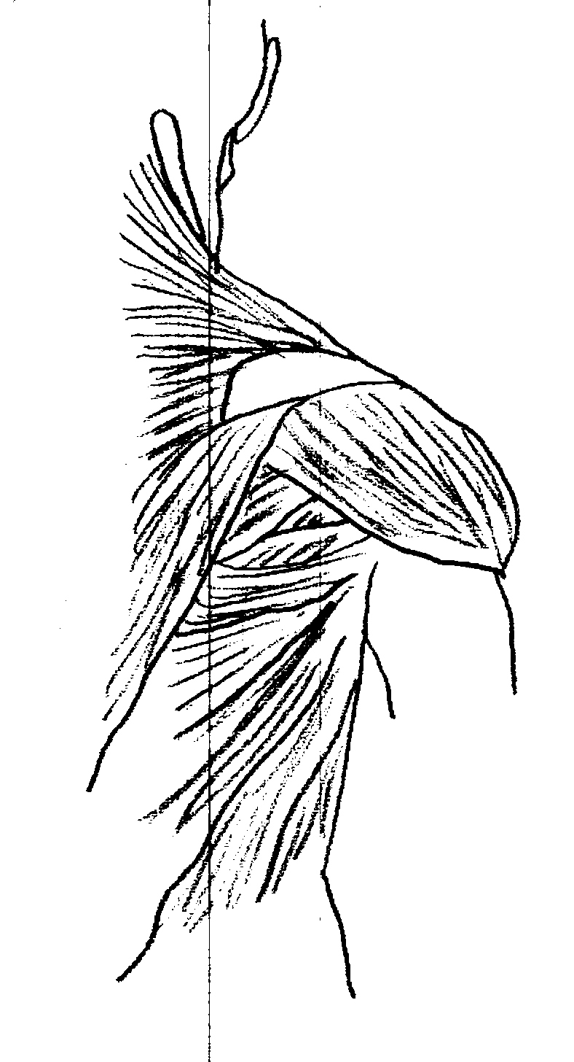
Trapezius
Latissiums dorsi
Deltoid
Figure 3: Trapezius, Latissimus dorsi & Deltoid

Group C Muscles

This group covers the large, flat muscles that arise from the trunk and pass to the upper arm. Their main roles are strength and flexibility. There are 4 muscles in this group:

- Pectoralis major
- Deltoid
- Latissimus dorsi
- Serratus anterior
Deltoid
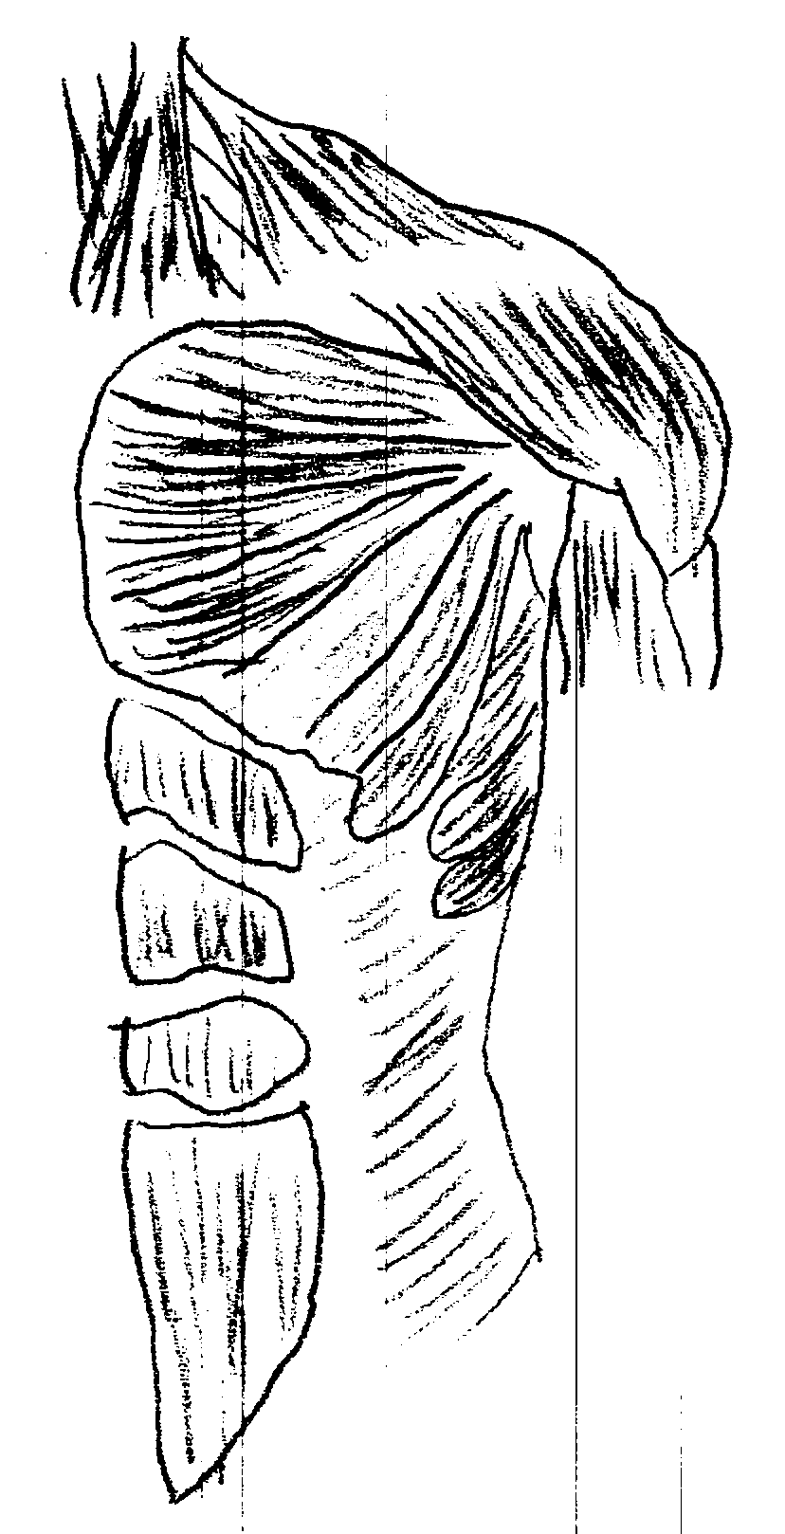
Pectoralis major
Serratus anterior

Figure 4: Group C Muscles

Pectoralis Major
(pectoris = chest; major = greater)

This muscle has 3 points of origin – the inner part of the collar bone, the manubrium and sternum, and, part of the costal cartilage of the ribs. It inserts into the greater tubercle of the humerus. It adducts the arm and rotates it inwards.

Deltoid

This originates on the outer part of the collar bone and along the entire spine of the posterior surface of the shoulder blade. It inserts along the shaft of the upper arm. Because its origin arches around the shoulder joint, this muscle can take part in all the movements of the arms. Its most important function is to lift (abduct) the arm straight out and upwards. However, the parts that arise from the posterior surface of the shoulder blade sing the arm back and rotate it outward. The parts that arise from the collar bone swing the arm forwards and rotate it inwards.

Latissimus Dorsi
(latus = side, dorsum = slope of hill)

This muscle originates from the lower half of the spinal column down to the sacrum and out to the crest of the hip bone. It inserts onto the humerus. It pulls the arm in behind the back.

Serratus Anterior
(sera = saw, ante = in front of)

This muscle originates from 8, 9 or 10 ribs and passes backwards along the rib cage and in behind the shoulder blade. Its inserts into the medial inner border of the shoulder blade. It stabilises the shoulder.
The Elbow

Movements occur at the elbow at three separate joints – the hinge joint between the humerus and ulna, the ball and socket joint between the humerus and radius and the pivot joint between the ulna and radius. This allows for flexion and extension of the arm as well as rotation at the elbow joint.

Elbow Flexors

The three most important flexors are:

- Biceps brachii (two-headed arm muscle)
- Brachialis (upper arm muscle)
- Brachioradialis (arm radius muscle)

Biceps brachii
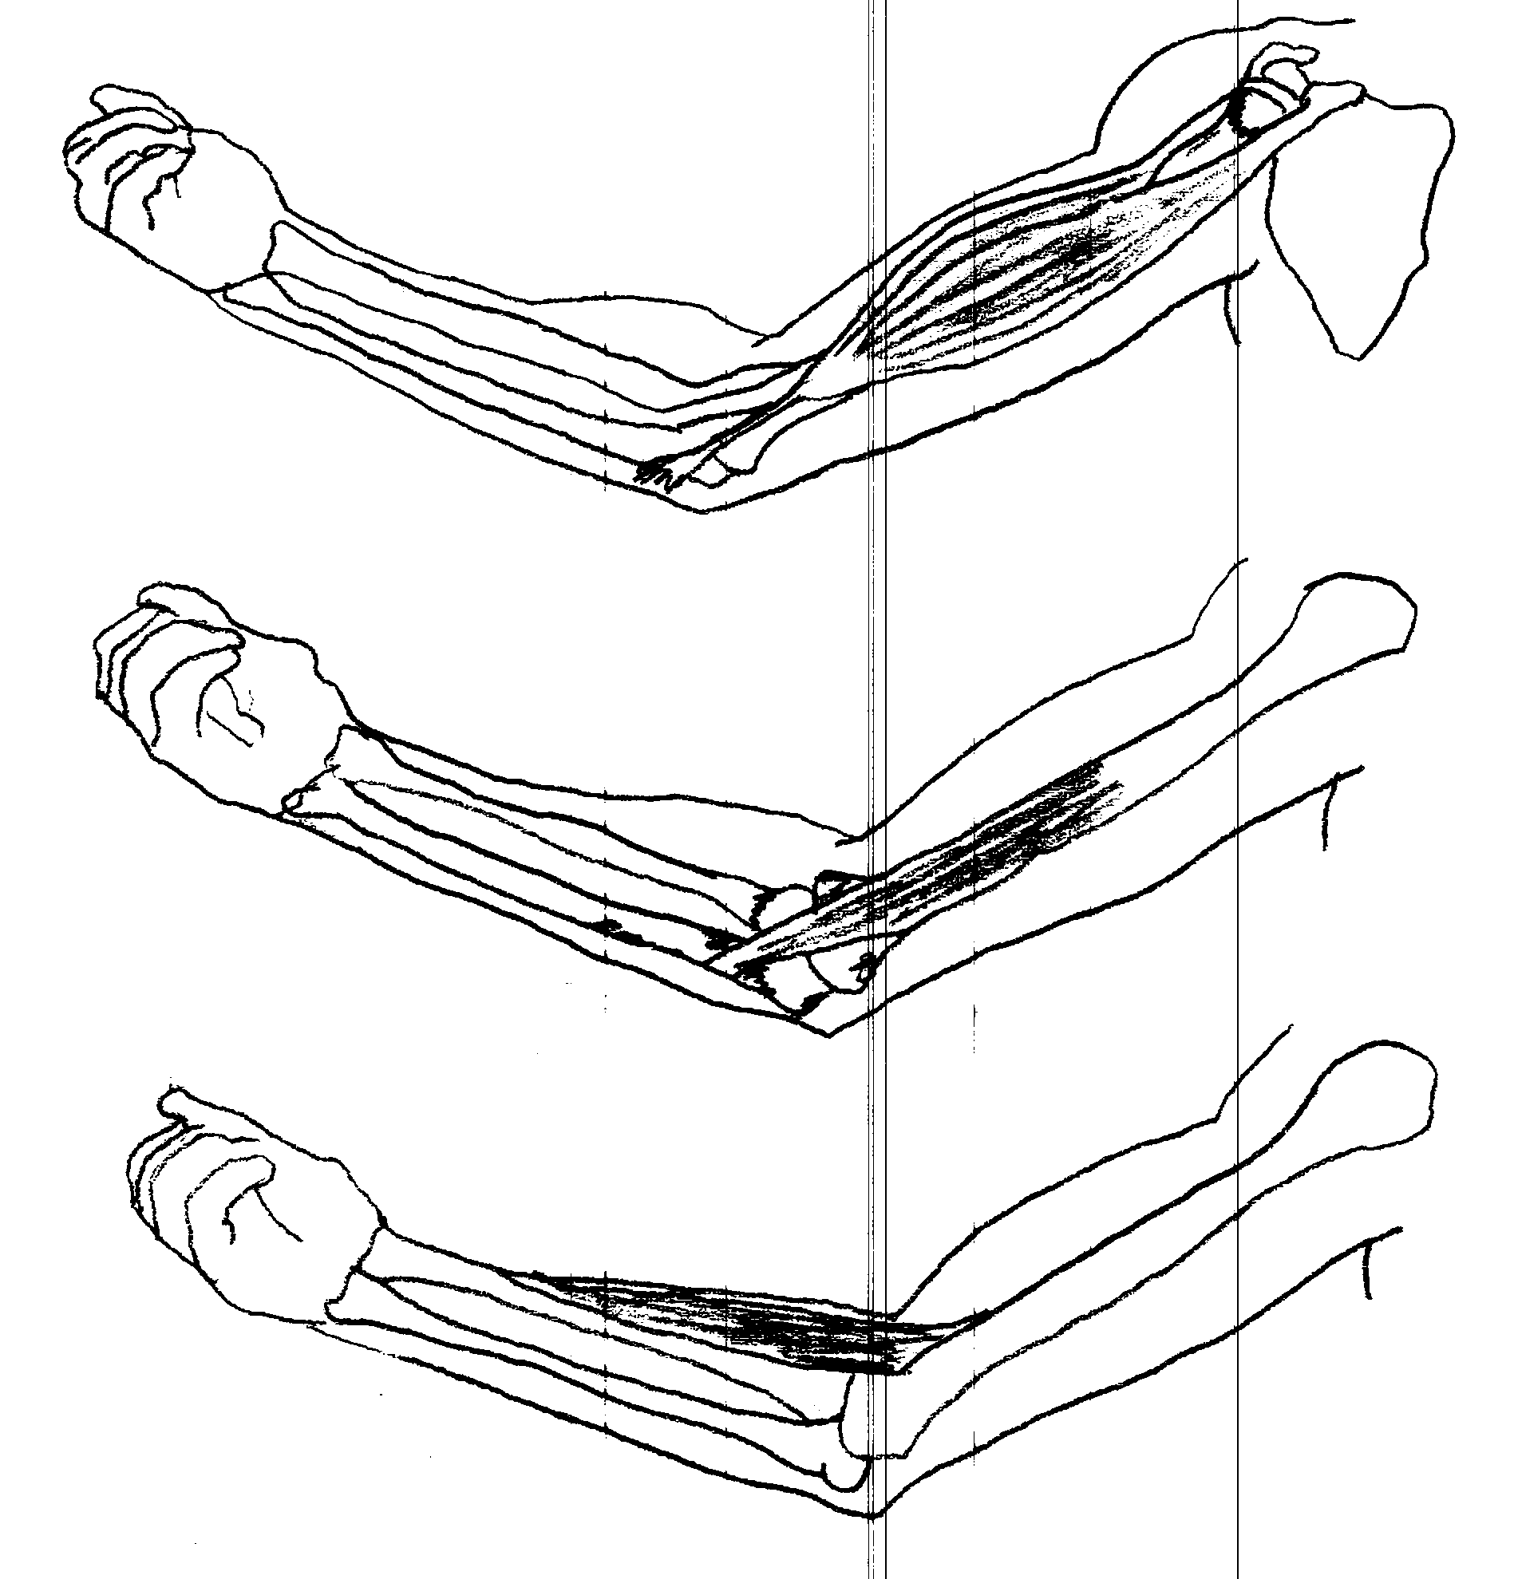
Brachialis
Brachioradialis

Figure 5: Elbow Flexors

All three muscles work together to flex (bend) the elbow joint. In addition, the biceps brachii also rotates the forearm so that the palm of the hand turns upwards and forwards (supinates), and swings the upper arm forwards.

Elbow Extensors

The anconeus and the triceps brachii are the elbow extensors. The triceps has 3 heads – one arises from the shoulder blade and the other two from the posterior surface of the upper arm – which enable it to extend (straighten) the elbow and to swing the arm backwards.

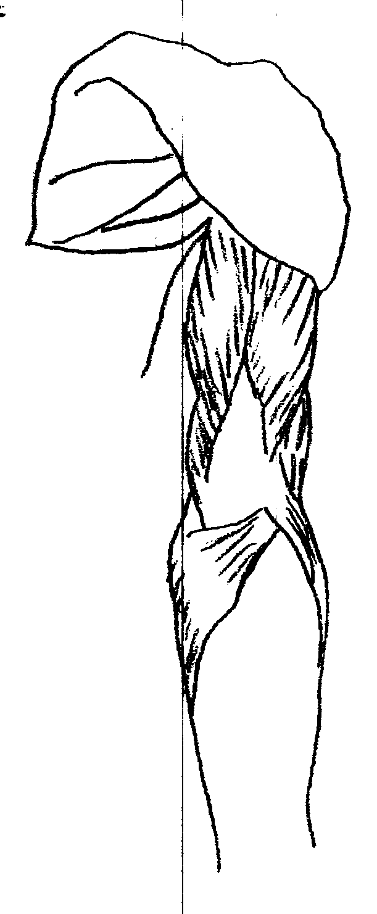
Triceps brachii
Anconeus

Figure 6: Elbow Extensors

The Wrist

The hand is made up of 8 carpal bones (wrist bones), five metacarpal bones (hand bones) and 14 phalanges (finger bones). Three of the carpal bones articulate with the radius to form the wrist joint. The hand changes position by movement of the wrist. The movements allowed at the wrist joint are:

- flexion (palm towards you)
- extension (palm away from you)
- abduction (flat hand tilted outwards)
- adduction (flat hand tilted inwards)

The following muscles are the main wrist and hand flexors:

- Flexor digitorum superficialis
- Palmaris longus
- Flexor digitorum profundus
- Flexor carpi ulnaris

Wrist extension is controlled by these muscles:

- Extensor carpi radialis longus
- Extensor carpi radialis brevis

Wrist abduction and adduction is controlled by:

- Flexor carpi radialis (abducts hand)
- Flexor carpi ulnaris (adducts hand)
- Abductor pollicis longus (radial abduction of wrist)
- Extensor policis longus & brevis (radial abduction of wrist)
- Extensor carpi ulnaris (ulna adduction of hand)

The movements involved in turning the hand are called pronation and supination.

Supination and pronation occur between the bones of the forearm (at the pivot joint formed by the ulna and radius) and not at the wrist joint. The muscles that bring about rotation of the forearm, and thereby turn the hand, are called pronators and supinators. The most important ones are:

- Pronator teres
- Pronator quadratus
- Biceps brachii
- Supinator

Muscles that control the movements of the fingers tend to originate in the forearm and insert on the corresponding fingers. Some of the muscles involved are:

- Extensor indicis
- Extensor digitorum
- Extensor digiti minimi
- Flexor digitorum superficialis
- Palmaris longus
- Flexor digitorum profundus

And that concludes the Muscle Map series. We hope this has helped locate and explain some of the major muscles of the body.

CHM NEWS

New Administrator

The College is delighted to welcome on board Michael Beattie as their new Administrator. Apart from ensuring the smooth running of the office, Michael will be responsible for dealing with student enquiries, redesigning the course prospectus, managing the design and implementation of the college website (which is drawing nearer to completion every day!!!) and for managing various ad hoc projects such as designing and installing the Japanese Garden at the college premises in Craigpark. We wish him all the best with his endeavours.

COUNSELLING CORNER

Change of Counselling Accrediation Body

The College of Holistic Medicine’s application for the 3-year Advanced Diploma in Therapeutic Counselling to be accredited by BACP has just completed its course inspection stage. Several classes were inspected and said to present very high standards, but, even more encouraging, the inspectors felt the therapeutic model, developed by Ron Rieck, was far superior to anything else they had seen. They were so impressed, they even suggested that Ron publish books and/or articles about it.

Although not yet confirmed, full accreditation with the BACP is anticipated shortly.

The Dalai Lama Comes to Glasgow

In case you didn’t know, Nobel Peace Prize winner His Holiness the Dalai Lama will be visiting Glasgow for 4 days from 29 May to 1 June 2004 to hold a series of lectures and talks on Buddhist wisdom at the Scottish Exhibition and Conference Centre (SECC).

According to his website “His Holiness’s programme will have something for everyone, regardless of their familiarity with Buddhism. His public talk will give everyone a chance to consider the moral and ethical challenges we face in the 21st Century. He will then give three days of teachings aimed at more experienced students of Buddhism – although it should be stressed that every event will be open to all:

Saturday 29 May 2004

A public talk preceded by a festival day for Tibet with monks from Tashi Lhunpo Monastery and other events.

Sunday 30 May – Tuesday 1 June 2004

Teachings on:

- Kamalashila’s ‘Middle Stages of Mediation’
- Togme Sangpo’s ‘37 Bodhisattva Practices’”

Further information on ticket prices and how to book can be obtained from the following website:

www.dalailama2004.org.uk

BUILDING YOUR BUSINESS

PART 4 – Reaching Clients
By Jill Maden

Reaching Skills & Tools

In Part 3 we took the approach of “see what the market needs and fill it”. In this Part, we take the opposite view of “deciding what you want and going for it”.

Starting Out

When you first start out in any field you generally don’t have enough experience to know what your ideal client or type of work would be. All you know is that you have this great new skill to offer and you want to make it available to as many people as possible. To start your practice, Monica Roseberry in her book “Marketing Massage” suggests you use the “10 x 10 Rule”. The 10 x 10 Rule states that you should “Set a goal for 10 new clients; talk to everyone within 10 feet of you, somehow including the word massage; and keep talking until you get those 10 clients.”

To ensure that these 10 clients can then book an appointment, she suggests using the following tools:

- Business Cards – at minimum, this should include you name, your title and your phone number so people know what you do and how to get in touch with you. Have these available at all times and give out freely.

- An Appointment Book – so that when they call, you are ready. Always make sure your appointment book is near the phone and kept up to date.

- An Address Book with Telephone List – this should include your client contact details together with directions of how to get to them if you do house visits. Ideally, this will be part of your appointment book.

- A Telephone and Answering Machine – if you are working from home or do not have access to a receptionist, make sure you have a separate business telephone number and an answering machine. First impressions are very important and if the telephone goes unanswered or is answered by someone with poor telephone skills, it may not create the most professional impression. Therefore, get a separate business number and answering machine so that when you can’t answer the phone yourself, your answering machine creates the right impression.

- A Professional Introduction – sometimes known as an “elevator introduction”, it is important to have a brief 30 second – 1 minute introduction of what you do. Then when people ask you what you do, you can get the key points across smoothly and without sounding pushy.

Once Experience is Gained

As you get more and more clients, you start to get a feel for what you are good at, what aspects of your trade you enjoy doing and what type of people you like working with.

At this stage, Monica recommends reviewing the following areas so that you can build your dream practice more quickly and effectively:

- Knowing yourself
- Choosing your ideal clients/niche market
- Finding your ideal clients

Knowing Yourself

This area covers several aspects:

- Your Ideal Life – take out 4 sheets of paper and label them “My Ideal Day”, “My Ideal Week”, “My Ideal Month” and “My Ideal Year”. Set yourself a 3 minute time limit for each page and write as quickly and unconsciously as you can. When you have finish, highlight the lines that are most important to you and keep these in mind when designing your ideal practice.

- Your Ideal Practice – in designing your ideal practice, write down what you want in each of the following areas:

- What kind of hands on work you want to do – do you want to do massage for relaxation or treating complicated sports injuries? Do you want to use your counselling skills to treat deep rooted psychological problems or just to help people find a bit of direction? What other skills can you offer or develop?

- What benefits you want to offer your clients – do you offer pain relief, emotional support, a place where people can cry, a chance for people to connect?

- What special additions can you offer – do you have some specialist knowledge in areas such as diet, exercise, breathwork, crystals, etc? This can also include things like what will your clients see (art work, equipment, colours, certificates); touch (oils, creams, sheets, towels, face rest, temperature, your hands); hear (music, conversation, silence, ambient sounds); taste (refreshments, drinks); smell (body & breath, oils & lotions, candles); feel (showers, mineral soaks); learn (new skills, self-awareness, understanding of the body); act on (exercise, stretching, posture, movement).

- What setting would work best for you – do you want to work with other therapists or work on your own? Do you want to work in offices? Do you like fast paced sessions or prefer being able to take your time? Also consider some of the things under Special Additions in relation to what you’d like.

- What work time frame is most suitable for you – what would be your ideal number of days to work each week, and ideal number of hours on those days? Also consider how long each session should be and if and for how long you want for breaks.

Choosing Your Ideal Client

After working through the previous sections you may have started to notice some patterns emerging about yourself. Knowing these factors, you can now start to formulate the ideal client that would fit your dream practice. Write down a brief description of your ideal client using the demographic factors below. You can start the sentence with “My ideal clients is …”:

Client Demographics
Male and/or female
Profession
Income level
Age
Education
Marital status
Primary need
Type of work
Perception level
Massage experience
Frequency of sessions

For example: My ideal client is a male between 20 and 40 years old who is an amateur or professional athlete and earns in excess of £20,000 per year. They have previous massage experience and wants sessions every 1-2 weeks to improve their sports performance. They live locally and are part of a sports club or leisure centre.

Finding Your Ideal Clients

So now you know what you like to do, where you like to do it and the type of client you like to work with, now all you have to do is find them. Here are some ideas for finding your ideal clients:

- Informal referrals – tell your friends, family and colleagues the type of client you are looking for and ask them to refer anyone they know who matches that criteria.

- Client referrals – asking clients for referrals can be awkward, so sometimes it can be better to tell them, as part of your pre-treatment speil, that if the work you do meets their needs then you expect them to refer 2 people of a similar quality to themselves.

- Health professional referrals – making yourself and the type of work you do known to local health care professionals (i.e. GPs, chiropractors, osteopaths, physiotherapists, etc) who already work with your ideal client type is also a good way to reach new clients.

- Referral communities – look at the types of communities you want to reach. If you want to work with young male athletes for instance, where will you find them? If you know people in that community already, talk with them about what you can do to get yourself into the group. If you don’t know somebody, try putting a poster up or join the group and get networking.

- Networking Groups – try attending some formal networking groups such as Women Into Business, the Chamber of Commerce, Women’s Institute, the Rotary Club, etc and talk to as many people as you can. Be sure to have your business cards at the ready.

- Public Speaking – give a talk to local club or organisation that’s likely to have members that fit your ideal client description.

- Mutual Marketing Partners – these are businesses that already have your ideal client type. What can you offer that business to gain access to its clients? For instance, sticking with our example of young male athletes, a local sports store may already provide their clothing and/or equipment, therefore, could you do a joint promotion with them where they get a free massage with every £100 worth of sports clothing purchased? Or if you don’t want to give too many massages away, could you sponsor a competition, get your logo on the publicity for it and offer a massage as a prize?

- Exhibitions/Tradeshows – you could hire a stall at an alternative health care exhibition or a tradeshow that caters for the types of clients you’re looking for, i.e. a holiday show for people looking for luxurious therapies.

- Advertising – taking out advertising space can be expensive, but if you target it carefully by, say advertising in a company newsletter for the construction trade, this may be cheaper than glossy magazines and stand a better chance of reaching your ideal client group.

We hope these ideas have helped and look forward to the next issue in which the Building Your Business series continues with “Rebooking Clients”.

