Small Arms of the Netherlands Armed Forces

Acknowledgments
I would like to thank the membership of the etranger website. I have tried to fit the weaponry of The Netherlands where it should be because of their long association with the United Kingdom, so I used obsolete weaponry from that country and updated it. In doing so, I researched the entire site, both to keep with “canon”, and to meet my needs. Without every other member’s hard work, I would not have been able to contribute. Thank You

Messerecht MR-1
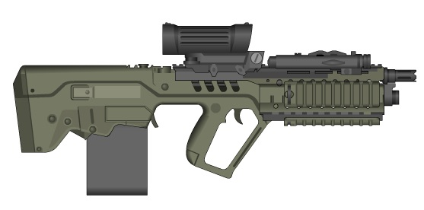

The Messerecht Corporation began making military small arms under license from Enfield in 2275, when the Dutch Military made the GSR.6 their standard infantry rifle. In 2297, the Dutch Army asked Messerecht to see how they could improve the design, while keeping commonality with the GSR.6. It delivered, keeping that weapon’s robustness and ease of operation, while putting it in a smaller package with only a slight loss of stopping power. They also added an integral 30mm grenade launcher to increase its capabilities against dug in opponents.
Type: 7.5mm bullpup rifle
Country: Netherlands
Weight: 3.8kg (unloaded)
Length: 65cm (Bulk = 2)
Action: Single Shots or Bursts
Ammunition: 7.5x37mm caseless ball
Muzzle Velocity: 900mps
Magazine: 50 round/ 5 round 30mm
Magazine Weight: 2kg
ROF: 3
Aimed Fire Range: 650m
Area Fire Burst: 10 rounds (AFV = 1)
Area Fire Range: 450m
DP Value: 0.8
Price: Lv500 (Lv2 for 100 round box)
30mm GL
Range: 150m (500m indirect)
Action: Single Shots
ROF: 3

Messerecht SSW-1 7.5mm Squad Support Weapon

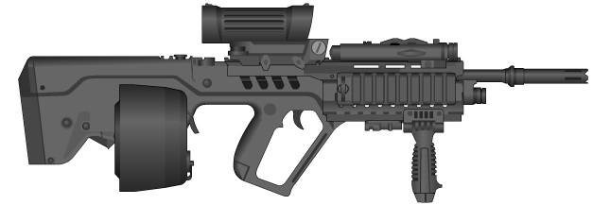

Based on the action of the current British medium machine gun, the L95, and chambered to the same round as the MR-1, the SSW-1 is a versatile weapon. The Messerecht Corp was asked again to make the weapon more suitable for the Dutch military. Using the same bullpup design as the MR-1, the SSW-1 is smaller and lighter than its contemporary, but not losing much in the way of accuracy or suppressive ability. The SSW-1 and its heavy 7.5mm round have become popular with the troops, as it is light, accurate and gives an excellent level of suppressive fire.
Type: 7.5mm Machine Gun
Country: The Netherlands
Weight: 5.5kg
Length: 90cm (LB) (Bulk = 3)
Action: Bursts
Ammunition: 7.5x37 caseless ball
Muzzle Velocity: 1225mps
Magazine: 300 round helical drum
Magazine Weight: 2.5kg
ROF: 5
Aimed Fire Range: 700m, 900m (Bipod)
Area Fire Burst: 20 rounds (AFB = 2)
Area Fire Range: 550m
DP Value: 0.9
Price: Not available on open market.

Messerecht PDW-1
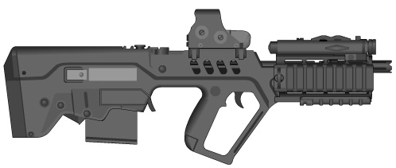

The PDW-1 is just the MR-1 in a shorter, lighter package for vehicle crews, special operations forces, and others needing a smaller weapon. On the PDW though, the sights have been changed to a reflex sight for easier maneuverability, while still retaining some of the MR-1’s targeting ability.
Type: 7.5mm bullpup rifle
Country: Netherlands
Weight: 3.2kg (unloaded)
Length: 60cm (Bulk = 2)
Action: Single Shots or Bursts
Ammunition: 7.5x37mm caseless ball
Muzzle Velocity: 900mps
Magazine: 50 round disposable box
Magazine Weight: .8kg
ROF: 3
Aimed Fire Range: 500m
Area Fire Burst: 10 rounds (AFV = 1)
Area Fire Range: 350m
DP Value: 0.8
Price: Lv450 (Lv2 for 100 round box)

FM P300S High-Cap
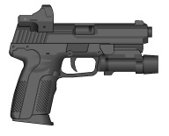
The ubiquitous FM P300 is utilized by Dutch infantry troops as a backup weapon for heavy weapons crews and snipers for self-defense purposes. It has a reflex sight and a laser targeting module for ease of targeting, making it popular with special operation forces. It is in no way thought of as a battlefield weapon.
Type: 5.6mm automatic
Country: Flanders
Weight (empty): 0.6 kg
Length: 20 cm (Bulk=0)
Action: Single shot and bursts
Ammunition: 5.6x28mm fixed ball cartridge
Muzzle Velocity: 650mps
Magazine: 20 round box
Magazine Weight: 0.1 kg
ROF: 7
Aimed Fire Range: 60 m
Area Fire Burst: 3 rounds (AFV=0.25)
Area Fire Range: 30 m
DP Value: 0.5
Price: Lv300 (Lv3 box 100)

FM Scherpschuttersgeweer 8mm (SSG-8) Sniper Rifle
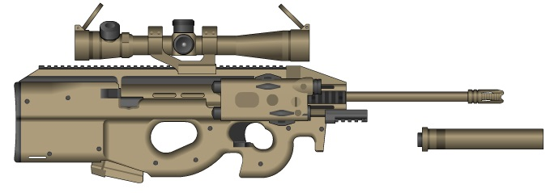

Although the SSG-8 is based on the action of the French FTE-8, the standard French sniper rifle of the Central Asian War period, it is a completely revitalized weapon. The SSG-8 utilizes a 10 round magazine with its own battery, and the rifle has its own internal power supply housed in the buttstock good for 60 rounds. The ubiquitous “S” shape bullpup design makes for a less bulky and unwieldy weapon and is popular with dedicated snipers. A model also exists for special operations use which fires an APHE round at reduced velocity, which in turn lowers the weapon’s firing signature.
Type: 8mm gauss sniper rifle
Country: Flanders
Weight (empty): 9.9kg
Length: 120cm (bulk = 4)
Action: Single shots
Ammunition: 8mm x 50mm flechette
Muzzle Velocity: 1500mps
Magazine: 10 round disposable box with internal cell
Magazine Weight: 1.6kg
ROF: 1
Aimed Fire Range: 1350m
DP Value: 2.7
Price: unavailable to the civilian market

Messerecht HG-1
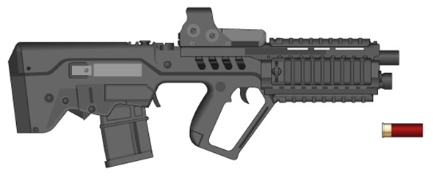
An improved military version of one of the company’s commercially successful automatic shotguns, the HG-1 is mechanically identical to its commercial counterpart but is encased in the same ergonomic body as the MR-1, and modified to use a 20 round magazine. The weapon comes equipped with a reflex sight and an integral laser pointer/flashlight.
Type: 18mm automatic shotgun
Country: Netherlands
Weight (Empty): 4kg
Length: 65cm (bulk = 2)
Action: single shot or bursts
Ammunition: 18mm × 60-mm fixed cartridge buckshot (10 × 6-mm slugs) or APHE
Muzzle Velocity: 450mps
Magazine: 20 round box magazine
Magazine Weight: 1kg
ROF: 2
Aimed Fire Range: 100m
Area Fire Burst: 5 rounds (AFV = 1)
Area Fire Range: 80m
DPV: 0.3 × 10 for buckshot or 3 for APHE (+ fragmentation burst radius = 3-m)
Price: unavailable on the civilian market
Available ammunition types
18mm Flechette: As per standard buckshot, except Aimed Fire Range: 150 meters, Area Fire Range: 100 meters.
18mm Rifled Slug: Area Fire Burst: 3 rounds (AFV = 0.25), DPV: 1.0
9/18mm Sabot: Aimed Fire Range: 180 meters (Area Fire Range standard), Area Fire Burst: 9 rounds (AFV = 0.9), DPV: 0.9
18mm Frangible Slug (Close combat, limited penetration round): Aimed Fire Range: 12 meters, Area Fire Range: 12 meters, DPV 1.0, Note: Double armor value when determining armor penetration.
18mm Baton Round: Aimed Fire Range: 60 meters, Area Fire Range: 40 meters, Area Fire Burst: 9 rounds (AFV = 0.9), DPV: 0.3 (blunt trauma only)

Jager Anti-Vehicle Missile System
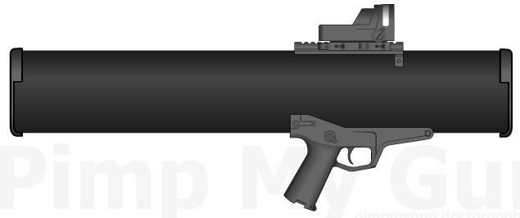
The Jager AVMS is a reusable, shoulder fired, anti-armor system; currently in use with the armies of both The Netherlands and Flanders. It is a robust weapon, and easy to use. A squad-level support weapon intended for use by light infantry formations, the Jager AVMS consists of a launcher unit with a variable magnification day and thermal imager (up to x10) and targeting software that assists gunners in target identification, ranging and passive IFF tasks.
Type: Shoulder fired Anti-Tank weapon
Country: Netherlands
Launcher weight: 8kg
Missile weight:3.5kg
Range: 1500m
Guidance: Automatic following gunner lock on
Homing value: 15
Attack angle: Selectable
DP: Tamped explosion(EP=25)
Price: unavailable on the civilian market

