FLOOR PLAN
(not to scale)

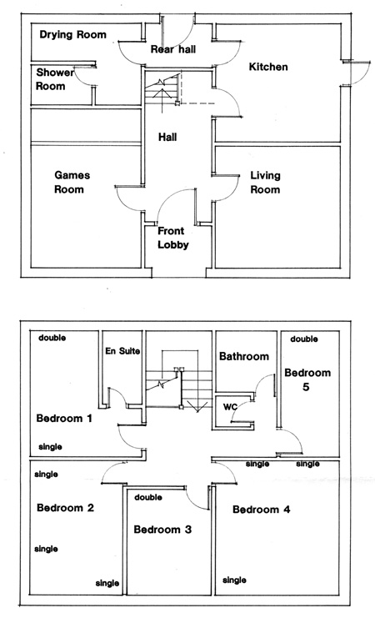

double bed settee in living room
and folding bed

Superb location
In the heart of
the Yorkshire Dales
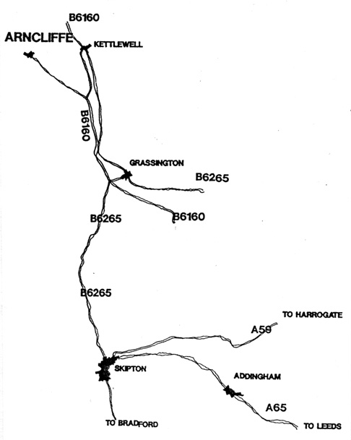
High Rylands is available throughout the year. For full details please contact Anita Walker

Tel: 01943 464083

Email: sundial@globalnet.co.uk
Web: www.founditmyself.com.

HIGH
RYLANDS

Arncliffe

Littondale

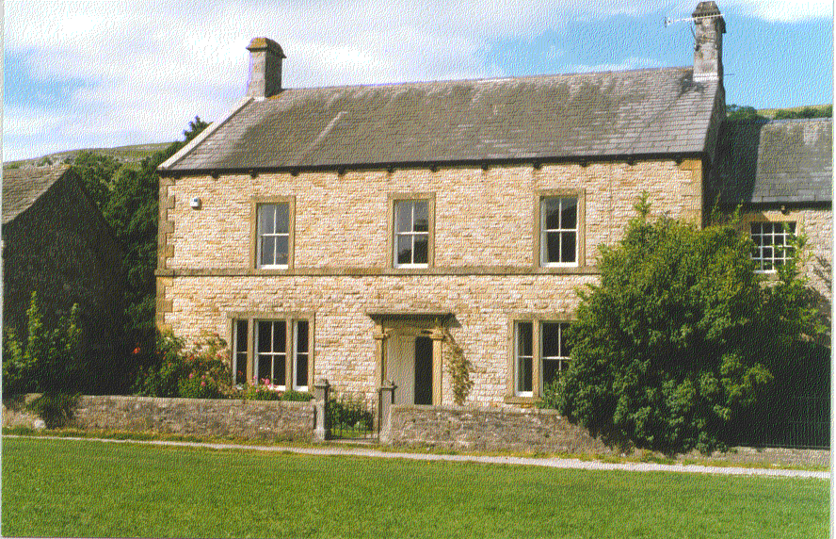

Yorkshire Dales
SELF CATERING
FARMHOUSE

for larger families and
parties up to 16

HIGH RYLANDS- a traditional 5 bedroom farmhouse in a superb location, ideal for walking, cycling, touring or just taking it easy in the heart of the Yorkshire Dales. Accommodation and facilities provide comfort practicality and outstanding value for groups, larger families and shared holidays. The oil-fired centrally heated accommodation includes:

LARGE SITTING ROOM: with comfortable sofas, open fire, CD and cassette player, colour TV, video dvd and dvd/video collection (second TV in bedroom 4).

FARMHOUSE DINING KITCHEN: including electric cooker, microwave, dishwasher, fridge, and extra large dining table. Thoughtfully equipped and with ample kitchenware. Payphone.

DRYING ROOM: warm room ideal for wet walking clothes or bathing towels! Includes washing machine and dryer. Freezer and additional fridge.

3 BATHROOMS: 2 house, 1 ensuite. One with shower, two with bath and shower. 4th toilet.

5 LARGE BEDROOMS: 3 double and 7 single beds, plus 1 folding bed, and 1 double bed-settee (in the living room) allow versatile accommodation for 10-16 guests. All bed linen provided.

GAMES ROOM: includes snooker table and full size table-tennis table.

GARDEN: with garden furniture, bbq and plenty of level enclosed space for the children. Stores for coal and wood (included). Ample parking.

ARNCLIFFE, LITTONDALE: High Rylands is situated on the Green in the peaceful and beautiful village of Arncliffe, with its pretty church and traditional inn.

Cowside Beck tumbles over limestone, though a natural swimming pool and on to meet the river Skirfare, a tributary of the Wharfe. These rivers provide excellent trout fishing, and a wealth of wildlife. Children will love to paddle, play boats or net tiddlers. High Rylands has its own river frontage, with access through a gated croft to the rear.

Riverside meadows offer leisurely strolls, whilst for the more serious walker, the hills beckon towards Malham, Kettlewell, Bucken or the ‘3 Peaks’. Whether for a few hours or a full day, guests can step out of the front door with a wide choice of circular routes. Cyclists will enjoy the Dales’ network of bridleways and ‘green roads’.

Littondale boasts truly spectacular scenery with limestone pavements and crags, heather moorland deep purple in summer and frosted in the clear winter sunlight. Spring is particularly beautiful with orchids, Bird’s Eye primrose, Saxifrage and countless other botanical delights. Littondale is a bird lover’s paradise too, with wagtails, dippers, kingfishers and other river birds contrasting with the splendour of the resident Peregrines and other birds of prey.

WHAT IF IT RAINS? Of course it can rain, but then the hillsides sparkle with life and the streams are at their most beautiful. Best of all, when the clothes are hung up in High Rylands’ purpose designed drying room; you will enjoy all the more, a long soak in a steaming hot bath and a drink before the open fire.

PLACES OF INTEREST: High Rylands also provides a good base for touring by car. The village of Grassington, with its cobbled square, is a short drive, and the ancient town of Skipton with its markets and castle, is less than 30 minutes away. Other places of interest within easy reach include Aysgarth, famous for its spectacular falls, Hawes with its creamery and Dales museum, Haworth and its surrounding ‘Bronte Country’, Settle and the spectacular caverns at White Scar Caves and Stump Cross Caverns. History abounds with Rievaulx, Fountains and Bolton Abbey, and castles at Middleham, Richmond and Bolton. Even the cities of York with its medieval walls, Minster and museums, Leeds new home to the Royal Armouries, or Bradford with the Museum of Photography and Salts Mill Gallery, are an easy day trip.

EATING OUT: Substantial bar meals at most local pubs including Litton, Threshfield Kettlewell and Kilnsey. Good variety of pubs and restaurants in Grassington. For that special night out, book into the restaurant at the Angel at Hetton.

SHOPS AND SERVICES: Most shops, including, butcher, grocer, chemist, maps, ironmongers, walking gear etc at Grassington. Petrol at Threshfield near Grassington.All facilities including large supermarkets at Skipton, and Settle.

